'SELECT DISTINCT ponumber, poitem FROM podelivery

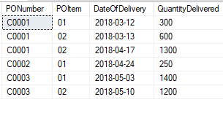

Write a stored procedure to determine maximum quantity delivered and count of the products.